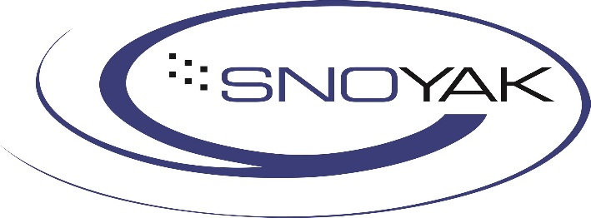
SnoYak Limited Warranty

Warranty Coverage
We warrant all adaptive skiing equipment manufactured by our company to be free from defects in materials and workmanship for a period of ONE (1) YEAR from the date of original purchase. This warranty applies only to the original retail purchaser and is non-transferable.

Warranty Terms
Our Responsibility: If a product is found to be defective due to materials or workmanship, we will, at our sole discretion, repair or replace the defective product or component.
Proof of Purchase Required: All warranty claims must be accompanied by proof of purchase showing the date of sale.
Return Authorization: All products returned for warranty inspection must have prior return authorization, which can be obtained by contacting us via phone or email before return shipment.

Transportation and Shipping: The customer is responsible for all transportation and shipping costs associated with returning products for warranty service.
Non-Transferable: This warranty extends only to the original retail purchaser and cannot be transferred to subsequent owners.
Replacement Products: Any replacement products provided under this warranty are covered only for the remainder of the original warranty period.
What Is NOT Covered: This warranty does not cover damage caused by misuse, abuse, or neglect; normal wear and tear; skier error or improper use; improper assembly, mounting or installation; product used for commercial rental purposes; product that has been modified or repaired by unauthorized parties; damage incurred during shipping or transportation.

